- Introduction

  - Digital library

As we all know digital library is also known as online library in this project we will learn about digital library , type of digital library , features of digital library , advantage or disadvantage of digital library



Figure 1: Digital library

  - Second Heading

Advantages of digital library
1.2.1 Sub heading
Disadvantages of digital library



- Type of digital library

There are mainly three types of digital Library
- National digital library
- Traditional Library
- Digital archive
national library established by a government as a country's preeminent repository of information. Unlike public libraries, these rarely allow citizens to borrow books.
Traditional Libraries gives emphasis on storage and preservation of physical items, particularly books and periodicals those in which librarian were a custodian of the library.
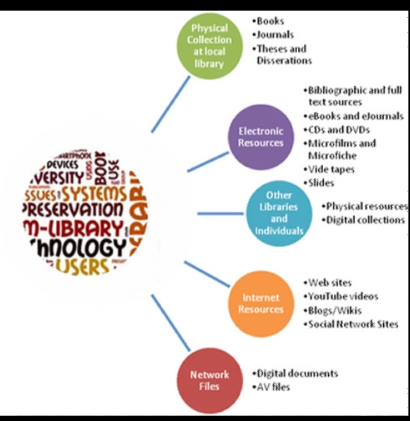
Digital archive :A comprehensive Agile software development company advancing your business strategies by building custom cloud-based software with integrated .

- Features of digital library

Figure 2: features of digital library



Figure 3: logo of digital library

- Future development

Ital Large scale digitization projects are underway at Google, the Million Book Project, and Internet Archive. With continued improvements in book handling and presentation technologies such as optical character recognition and development of alternative depositories and business models, digital libraries are rapidly growing in popularity.


- Summary and Future Work
Digital library is a collection of textual, numeric data, scanned images, graphics, audio & video recordings that provides access to digital collection for ease of retrieval of information to the users. In digital library there are three types of digital library traditional Library, national library , digital achieve. There are many different types of features in digital library . The government are continuing developing the digital library .

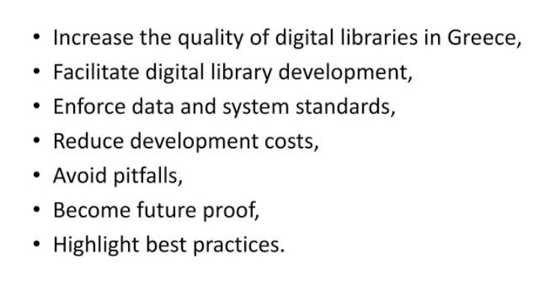

References

- Jing, L., Ming, L., Bin, Y., Wenlong, L., A Novel Energy Efficient MAC Protocol for Wireless Body Area Network. China communication, Feb. 2015.
- Negra, R., Jemili, I., Belghith, A.: Wireless Body Area Networks: Applications and Technologies. Procedia Computer Science 83, 1274 – 1281 ( 2016 )
- Yuce, M.R.: Implementation of wireless body area networks for healthcare systems. In: Sensors and Actuators A: Physical, Vol 162, Issue 1, Pages 116-129. Elsevier B.V (2010)
- Dabhi, K., Mahet, A.: Internet of Nano Things-The Next Big Thing. In: International Journal of Engineering Science and Computing, vol 7 Issue No.4 (2017)
- Negra, R., Jemili, I., Belghith, A.: Wireless Body Area Networks: Applications and Technologies. Procedia Computer Science 83, 1274 – 1281 ( 2016 )
- Yuan, X., Li, C., Ye, Q., Zhan, K., Cheng, N., Zhan, N., Shen, X.: Performance Analysis of IEEE 802.15.6-Based Coexisting Mobile WBANs with Prioritized Trafﬁc and Dynamic Interference. In: IEEE Transactions on Wireless Communications (Volume: 17, Issue: 8, Aug. 2018)
- Adhikary S., Chattopadhyay S., Choudhury S.: A Novel Bio-inspired Algorithm for Increasing Throughput in Wireless Body Area Network (WBAN) by Mitigating Inter-WBAN Interference. In: Chaki R., Cortesi A., Saeed K., Chaki N. (eds) Advanced Computing and Systems for Security. Advances in Intelligent Systems and Computing, vol 667. Springer, Singapore (2018)
- Peng, H., Tian, Y., Kurths, J., Li, L., Yang, Y., Wang, D.: Secure and energy-efﬁcient data transmission system based on chaotic compressive sensing in body-to-body networks. IEEE Trans. Biomed. Circ. Syst. 11(3), 558–573 (2017)
- Samanta, A., Misra, S.: Energy-efﬁcient and distributed network management cost minimization in opportunistic wireless body area networks. IEEE Trans. Mobile Comput. 17, 376–389 (2017)
- Ahmad, S.S., Razzaque, M.A., Inmaculada T.R., Hussain, N.: IEEE 802.15.6 Standard in Wireless Body Area Networks From a Healthcare Point of View. The 22nd Asia-Pacific Conference on Communications (APCC2016)
- Yi, C., Wang, L., Li, Y.: Energy efﬁcient transmission approach for WBAN based on threshold distance. IEEE Sensors J. 15(9), 5133–5141 (2015)
- Misra, S., Moulik, S., Chao, H.-C.: A cooperative bargaining solution for priority-based data-rate tuning in a wireless body area network. IEEE Trans. Wirel. Commun. 14(5), 2769–2777 (2015)
- Walsh, M.J., Hayes, M.J.: Throughput rate control for an 802.15.4 wireless body area network using static and low order anti-windup techniques. In: Proc. Mediterranean Conf. Control Autom, pp.1–6 (2007)
- Eberhart, R., Kennedy, J.: A New Optimizer Using Particle Swarm Theory. Sixth International Symposium on Micro Machine and Human Science, 0-7803-2676-8/95
- Kalaiselvi, K., Suresh, G.R. & Ravi, V.: Genetic algorithm based sensor node classiﬁcations in wireless body area networks (WBAN). Cluster Comput (2018)
- Nadeem, Q., Javaid, N., Mohammad, S.N., Khan, M.Y., Gull, M.: SIMPLE: Stable Increased-throughput Multi-hop Protocol for Link Efﬁciency in Wireless Body Area Networks. 26, Jul. 2013.

